**­­­­Computer Architecture Lab Report Week 10**

**Full name: Nguyễn Hồng Phúc**

**Student ID: 20225659**

Assignment 1

**Code:**

.eqv IN_ADRESS_HEXA_KEYBOARD 0xFFFF0012

# receive row and column of the key pressed, 0 if not key pressed

# Eg. equal 0x11, means that key button 0 pressed.

# Eg. equal 0x28, means that key button D pressed.

.eqv OUT_ADRESS_HEXA_KEYBOARD 0xFFFF0014

.data

nl: .asciiz "\n"

.text

main:

li $t1, IN_ADRESS_HEXA_KEYBOARD

li $t2, OUT_ADRESS_HEXA_KEYBOARD

li $t3, 0x01 # check row 4 with key C, D,E, F

li $t4, 0x02 # check row 4 with key C, D,E, F

li $t5, 0x04 # check row 4 with key C, D,E, F

li $t6, 0x08 # check row 4 with key C, D,E, F

li $t0, 0

polling:

beq $t0, 100, exit

sb $t3, 0($t1 ) # must reassign expected row

lb $a0, 0($t2) # read scan code of key button

bne $a0, $zero, print

sb $t4, 0($t1 ) # must reassign expected row

lb $a0, 0($t2) # read scan code of key button

bne $a0, $zero, print

sb $t5, 0($t1 ) # must reassign expected row

lb $a0, 0($t2) # read scan code of key button

bne $a0, $zero, print

sb $t6, 0($t1 ) # must reassign expected row

lb $a0, 0($t2) # read scan code of key button

bne $a0, $zero, print

j continue

print:

li $v0, 34 # print integer (hexa)

syscall

la $a0, nl

li $v0, 4

syscall

continue:

addi $t0, $t0, 1

sleep:

li $a0, 3000 # sleep 3s

li $v0, 32

syscall

back_to_polling:

j polling # continue polling

exit:

**Kết quả:**

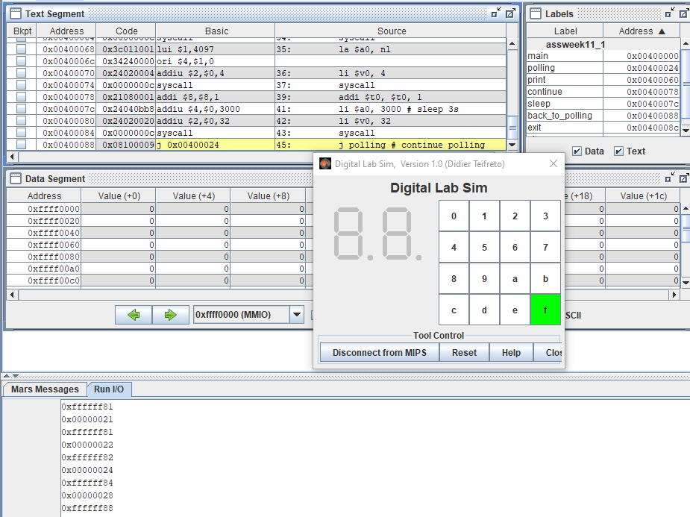

Assignment 2

**Code:**

.eqv IN_ADDRESS_HEXA_KEYBOARD 0xFFFF0012

.data

Message: .asciiz "Oh my god. Someone's presed a button.\n"

#~~~~~~~~~~~~~~~~~~~~~~~~~~~~~~~~~~~~~~~~~~~~~~~~~~~~~~~~~~~~~~~~~

# MAIN Procedure

#~~~~~~~~~~~~~~~~~~~~~~~~~~~~~~~~~~~~~~~~~~~~~~~~~~~~~~~~~~~~~~~~~

.text

main:

#---------------------------------------------------------

# Enable interrupts you expect

#---------------------------------------------------------

# Enable the interrupt of Keyboard matrix 4x4 of Digital Lab Sim

li $t1, IN_ADDRESS_HEXA_KEYBOARD

li $t3, 0x80 # bit 7 of = 1 to enable interrupt

sb $t3, 0($t1)

#---------------------------------------------------------

# No-end loop, main program, to demo the effective of interrupt

#---------------------------------------------------------

Loop:

nop

nop

addi $v0, $zero, 32

li $a0, 200

syscall

nop

nop

b Loop # Wait for interrupt

end_main:

#~~~~~~~~~~~~~~~~~~~~~~~~~~~~~~ ~~~~~~~~~~~~~~~~~~~~~~~~~~~~~~~~~~~

# GENERAL INTERRUPT SERVED ROUTINE for all interrupts

#~~~~~~~~~~~~~~~~~~~~~~~~~~~~~~~~~~~~~~~~~~~~~~~~~~~~~~~~~~~~~~~~~

.ktext 0x80000180

#--------------------------------------------------------

# Processing

#--------------------------------------------------------

IntSR: addi $v0, $zero, 4 # show message

la $a0, Message

syscall

#--------------------------------------------------------

# Evaluate the return address of main routine

# epc <= epc + 4

#--------------------------------------------------------

next_pc:mfc0 $at, $14 # $at <= Coproc0.$14 = Coproc0.epc

addi $at, $at, 4 # $at = $at + 4 (next instruction)

mtc0 $at, $14 # Coproc0.$14 = Coproc0.epc <= $at

return: eret # Return from exception

**Kết quả:**

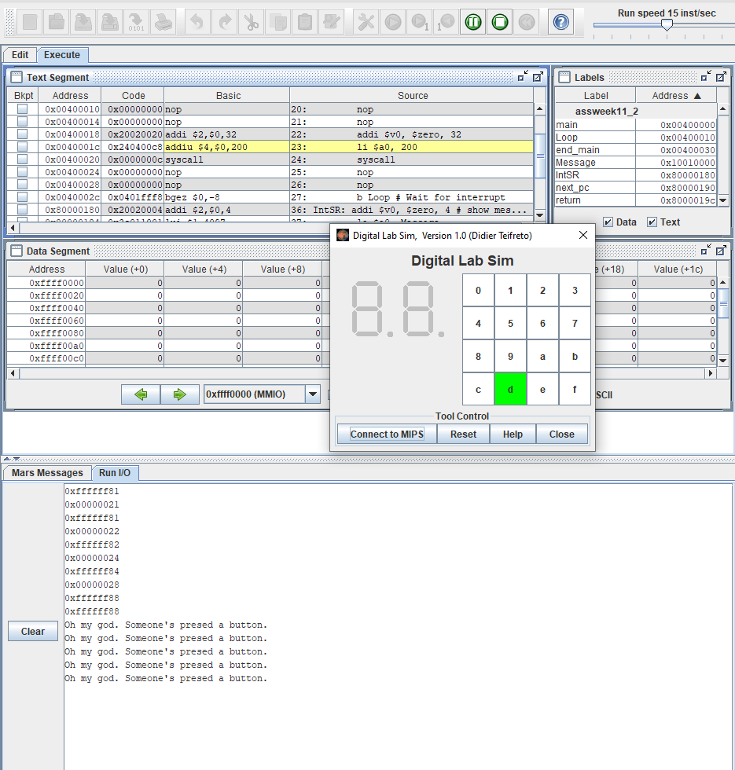

Assignment 3

**Code:**

.eqv IN_ADRESS_HEXA_KEYBOARD 0xFFFF0012

.eqv OUT_ADRESS_HEXA_KEYBOARD 0xFFFF0014

.data

Message: .asciiz "Key scan code "

#~~~~~~~~~~~~~~~~~~~~~~~~~~~~~~~~~~~~~~~~~~~~

# MAIN Procedure

#~~~~~~~~~~~~~~~~~~~~~~~~~~~~~~~~~~~~~~~~~~~~

.text

main:

#---------------------------------------------------------

# Enable interrupts you expect

#---------------------------------------------------------

# Enable the interrupt of Keyboard matrix 4x4 of Digital Lab Sim

li $t1, IN_ADRESS_HEXA_KEYBOARD

li $t3, 0x80 # bit 7 = 1 to enable

sb $t3, 0($t1)

#---------------------------------------------------------

# Loop an print sequence numbers

#---------------------------------------------------------

xor $s0, $s0, $s0 # count = $s0 = 0

Loop:

addi $s0, $s0, 1 # count = count + 1

prn_seq:

addi $v0,$zero,1

add $a0,$s0,$zero # print auto sequence number

syscall

prn_eol:

addi $v0,$zero,11

li $a0,"\n" # print endofline

syscall

sleep:

addi $v0,$zero,32

li $a0,500 # sleep 0,5 s

syscall

nop # WARNING: nop is mandatory here.

b Loop # Loop

end_main:

#~~~~~~~~~~~~~~~~~~~~~~~~~~~~~~~~~~~~~~~~~~~~

# GENERAL INTERRUPT SERVED ROUTINE for all interrupts

#~~~~~~~~~~~~~~~~~~~~~~~~~~~~~~~~~~~~~~~~~~~~

.ktext 0x80000180

#-------------------------------------------------------

# SAVE the current REG FILE to stack

#-------------------------------------------------------

IntSR:

addi $sp,$sp,4 # Save $ra because we may change it later

sw $ra,0($sp)

addi $sp,$sp,4 # Save $at because we may change it later

sw $at,0($sp)

addi $sp,$sp,4 # Save $sp because we may change it later

sw $v0,0($sp)

addi $sp,$sp,4 # Save $a0 because we may change it later

sw $a0,0($sp)

addi $sp,$sp,4 # Save $t1 because we may change it later

sw $t1,0($sp)

addi $sp,$sp,4 # Save $t3 because we may change it later

sw $t3,0($sp)

#--------------------------------------------------------

# Processing

#--------------------------------------------------------

prn_msg:

addi $v0, $zero, 4

la $a0, Message

syscall

get_cod:

li $t1, IN_ADRESS_HEXA_KEYBOARD

li $t3, 0x81 # check row 4 and re-enable bit 7

sb $t3, 0($t1) # must reassign expected row

li $t1, OUT_ADRESS_HEXA_KEYBOARD

lb $a0, 0($t1)

bne $a0, $zero, prn_cod

li $t1, IN_ADRESS_HEXA_KEYBOARD

li $t3, 0x82 # check row 4 and re-enable bit 7

sb $t3, 0($t1) # must reassign expected row

li $t1, OUT_ADRESS_HEXA_KEYBOARD

lb $a0, 0($t1)

bne $a0, $zero, prn_cod

li $t1, IN_ADRESS_HEXA_KEYBOARD

li $t3, 0x84 # check row 4 and re-enable bit 7

sb $t3, 0($t1) # must reassign expected row

li $t1, OUT_ADRESS_HEXA_KEYBOARD

lb $a0, 0($t1)

bne $a0, $zero, prn_cod

li $t1, IN_ADRESS_HEXA_KEYBOARD

li $t3, 0x88 # check row 4 and re-enable bit 7

sb $t3, 0($t1) # must reassign expected row

li $t1, OUT_ADRESS_HEXA_KEYBOARD

lb $a0, 0($t1)

bne $a0, $zero, prn_cod

prn_cod:

li $v0,34

syscall

li $v0,11

li $a0,'\n' # print endofline

syscall

#--------------------------------------------------------

# Evaluate the return address of main routine

# epc <= epc + 4

#--------------------------------------------------------

next_pc:

mfc0 $at, $14 # $at <= Coproc0.$14 = Coproc0.epc

addi $at, $at, 4 # $at = $at + 4 (next instruction)

mtc0 $at, $14 # Coproc0.$14 = Coproc0.epc <= $at

#--------------------------------------------------------

# RESTORE the REG FILE from STACK

#--------------------------------------------------------

restore:

lw $t3, 0($sp) # Restore the registers from stack

addi $sp,$sp,-4

lw $t1, 0($sp) # Restore the registers from stack

addi $sp,$sp,-4

lw $a0, 0($sp) # Restore the registers from stack

addi $sp,$sp,-4

lw $v0, 0($sp) # Restore the registers from stack

addi $sp,$sp,-4

lw $ra, 0($sp) # Restore the registers from stack

addi $sp,$sp,-4

lw $ra, 0($sp) # Restore the registers from stack

addi $sp,$sp,-4

return:

eret # Return from exception

**Kết quả:**

Assignment 4

**Code:**

.eqv IN_ADDRESS_HEXA_KEYBOARD 0xFFFF0012

.eqv COUNTER 0xFFFF0013 # Time Counter

.eqv MASK_CAUSE_COUNTER 0x00000400 # Bit 10: Counter interrupt

.eqv MASK_CAUSE_KEYMATRIX 0x00000800 # Bit 11: Key matrix interrupt

.data

msg_keypress: .asciiz "Someone has pressed a key!\n"

msg_counter: .asciiz "Time inteval!\n"

#~~~~~~~~~~~~~~~~~~~~~~~~~~~~~~~~~~~~~~~~~~~~~~~~~~~~~~~~~~~~~~~~~

# MAIN Procedure

#~~~~~~~~~~~~~~~~~~~~~~~~~~~~~~~~~~~~~~~~~~~~~~~~~~~~~~~~~~~~~~~~~

.text

main:

#---------------------------------------------------------

# Enable interrupts you expect

#---------------------------------------------------------

# Enable the interrupt of Keyboard matrix 4x4 of Digital Lab Sim

li $t1, IN_ADDRESS_HEXA_KEYBOARD

li $t3, 0x80 # bit 7 = 1 to enable

sb $t3, 0($t1)

# Enable the interrupt of TimeCounter of Digital Lab Sim

li $t1, COUNTER

sb $t1, 0($t1)

#---------------------------------------------------------

# Loop a print sequence numbers

#---------------------------------------------------------

Loop: nop

nop

nop

sleep: addi $v0,$zero,32 # BUG: must sleep to wait for Time Counter

li $a0,200 # sleep 200 ms

syscall

nop # WARNING: nop is mandatory here.

b Loop

end_main:

#~~~~~~~~~~~~~~~~~~~~~~~~~~~~~~~~~~~~~~~~~~~~~~~~~~~~~~~~~~~~~~~~~

# GENERAL INTERRUPT SERVED ROUTINE for all interrupts

#~~~~~~~~~~~~~~~~~~~~~~~~~~~~~~~~~~~~~~~~~~~~~~~~~~~~~~~~~~~~~~~~~

.ktext 0x80000180

IntSR: #--------------------------------------------------------

# Temporary disable interrupt

#--------------------------------------------------------

dis_int:li $t1, COUNTER # BUG: must disable with Time Counter

sb $zero, 0($t1)

# no need to disable keyboard matrix interrupt

#--------------------------------------------------------

# Processing

#--------------------------------------------------------

get_caus:mfc0 $t1, $13 # $t1 = Coproc0.cause

IsCount:li $t2, MASK_CAUSE_COUNTER# if Cause value confirm Counter..

and $at, $t1,$t2

beq $at,$t2, Counter_Intr

IsKeyMa:li $t2, MASK_CAUSE_KEYMATRIX # if Cause value confirm Key..

and $at, $t1,$t2

beq $at,$t2, Keymatrix_Intr

others: j end_process # other cases

Keymatrix_Intr: li $v0, 4 # Processing Key Matrix Interrupt

la $a0, msg_keypress

syscall

j end_process

Counter_Intr: li $v0, 4 # Processing Counter Interrupt

la $a0, msg_counter

syscall

j end_process

end_process:

mtc0 $zero, $13 # Must clear cause reg

en_int: #--------------------------------------------------------

# Re-enable interrupt

#--------------------------------------------------------

li $t1, COUNTER

sb $t1, 0($t1)

#--------------------------------------------------------

# Evaluate the return address of main routine

# epc <= epc + 4

#--------------------------------------------------------

next_pc:mfc0 $at, $14 # $at <= Coproc0.$14 = Coproc0.epc

addi $at, $at, 4 # $at = $at + 4 (next instruction)

mtc0 $at, $14 # Coproc0.$14 = Coproc0.epc <= $at

return: eret # Return from exception

**Kết quả:**

Assignment 5

**Code:**

.eqv KEY_CODE 0xFFFF0004 # ASCII code from keyboard, 1 byte

.eqv KEY_READY 0xFFFF0000 # =1 if has a new keycode ?

# Auto clear after lw

.eqv DISPLAY_CODE 0xFFFF000C # ASCII code to show, 1 byte

.eqv DISPLAY_READY 0xFFFF0008 # =1 if the display has already to do

# Auto clear after sw

.eqv MASK_CAUSE_KEYBOARD 0x0000034 # Keyboard Cause

.text

li $k0, KEY_CODE

li $k1, KEY_READY

li $s0, DISPLAY_CODE

li $s1, DISPLAY_READY

loop:

nop

WaitForKey:

lw $t1, 0($k1) # $t1 = [$k1] = KEY_READY

beq $t1, $zero, WaitForKey # if $t1 == 0 then Polling

MakeIntR:

teqi $t1, 1 # if $t0 = 1 then raise an Interrupt

j loop

#---------------------------------------------------------------

# Interrupt subroutine

#---------------------------------------------------------------

.ktext 0x80000180

get_caus:

mfc0 $t1, $13 # $t1 = Coproc0.cause

IsCount:

li $t2, MASK_CAUSE_KEYBOARD # if Cause value confirm

Keyboard..

and $at, $t1,$t2

beq $at,$t2, Counter_Keyboard

j end_process

Counter_Keyboard:

ReadKey:

lw $t0, 0($k0) # $t0 = [$k0] = KEY_CODE

WaitForDis:

lw $t2, 0($s1) # $t2 = [$s1] = DISPLAY_READY

beq $t2, $zero, WaitForDis # if $t2 == 0 then Polling

Encrypt:

addi $t0, $t0, 1 # change input key

ShowKey:

sw $t0, 0($s0) # show key

nop

end_process:

next_pc:

mfc0 $at, $14 # $at <= Coproc0.$14 = Coproc0.epc

addi $at, $at, 4 # $at = $at + 4 (next instruction)

mtc0 $at, $14 # Coproc0.$14 = Coproc0.epc <= $at

return:

eret # Return from exception

**Kết quả:**

